Github Desktop : <https://desktop.github.com/>

Download, install and login to your Github Account

Click Current Repository and Click Add. Choose Clone Repository

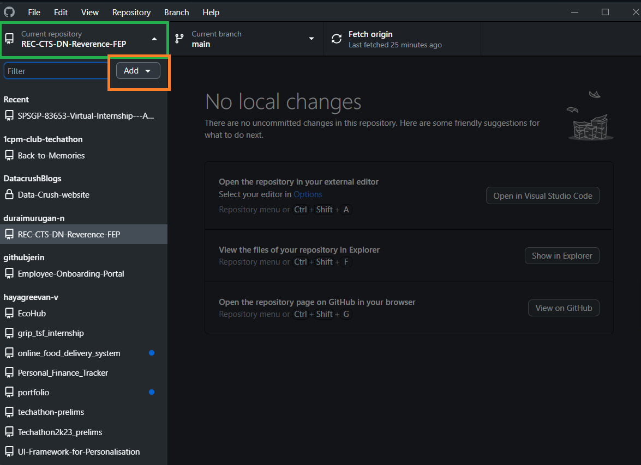

Click fetch origin, then click pull origin

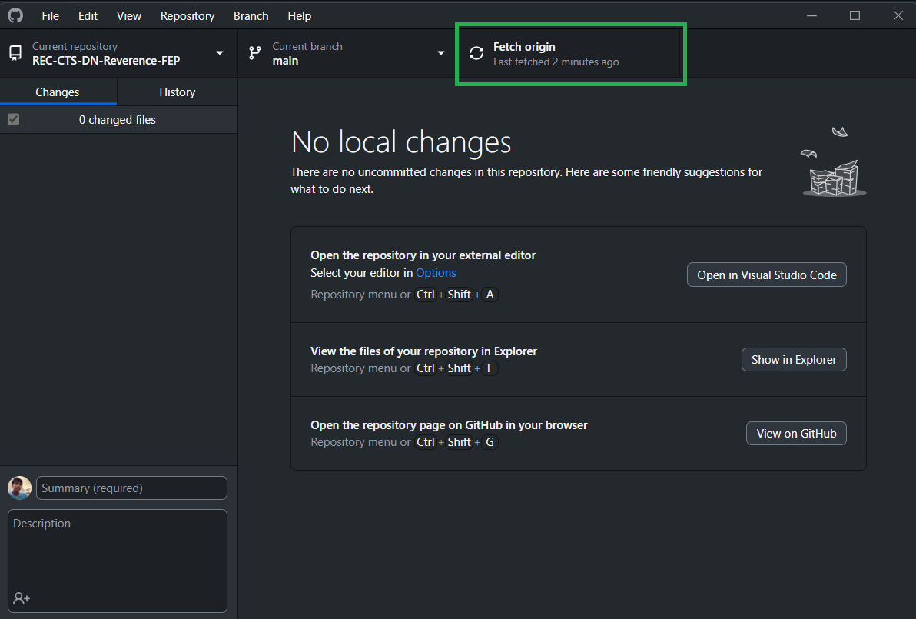

Choose this Repository and Define Local Path for the repository.

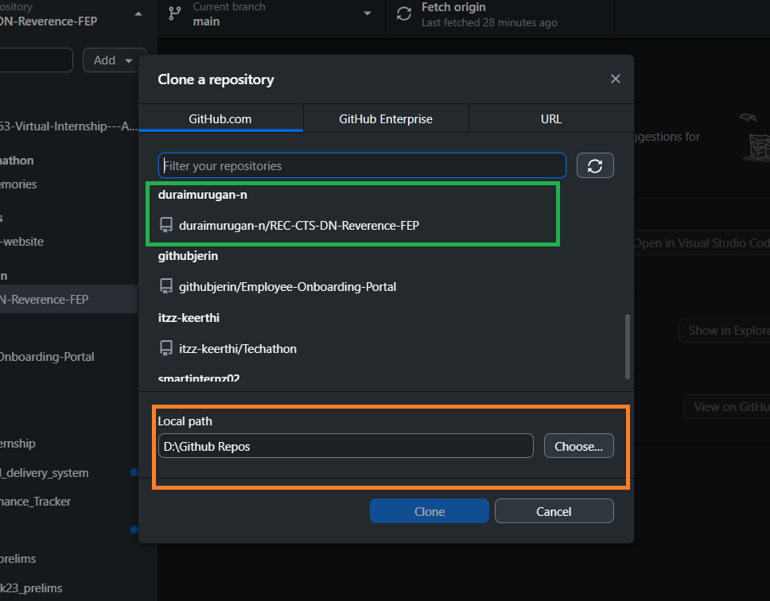

Open the Repository in visual studio

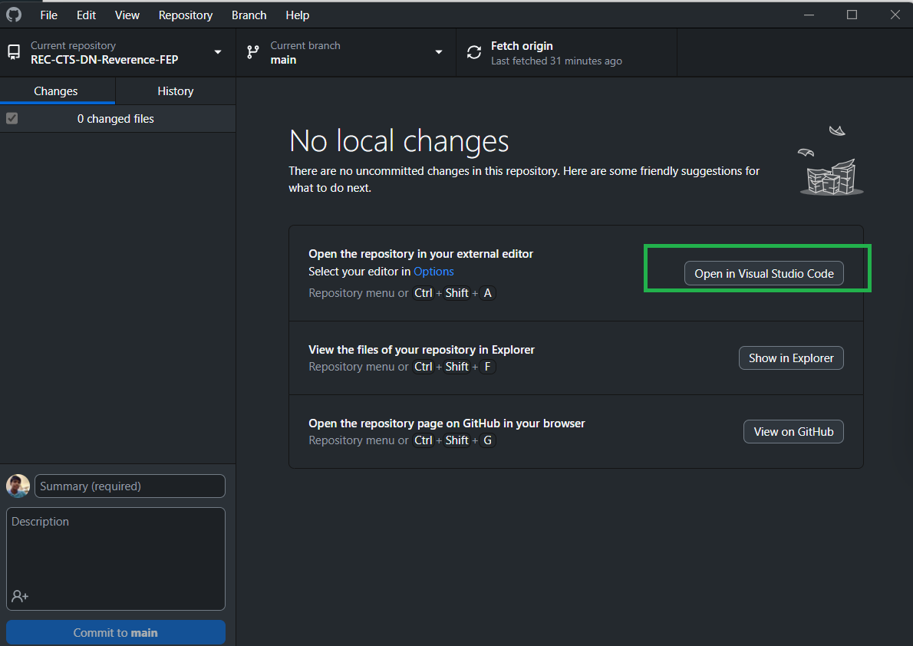

Open Terminal in VS Code:

Starting frontend :

**cd client**

**npm i**

**npm start**

Open Another Terminal for backend:

**cd server**

**npm i**

**npx nodemon server.js**

For Login to website:

Email: college email

Password: admin